The Ladies’ Section Newsletter – June /July 2022

Lady Captain’s Day, July 26th
Thank you to Lady Captain, Helena for organising a very enjoyable day for us. 42 ladies played in an individual stableford competition, which was followed by a very welcome Pimm’s and “high tea”. We were joined for the meal by Helena’s guests which included several past captains and former members of our section. It was lovely to see everyone, and the clubhouse was full of chatter and laughter. The “heads and tails raffle” was won by Bob Kenyon, The Scottish themed hat competition was decided by “clapometer” and won by our Lady President, Ruth Belcher. The Lady Captain’s Prize was won by Jo Cole with 45 points. The runner- up was Anne Ford with 39 points. Other prize winners were Joan Lawson (38 points), Vicky Northern (37 points), Ronnie Simpson (36 points), Liz Johnson (34 points) and Clair Bennett (34 points). Fabulous prizes, Helena – thank you! Helena thanked the ladies for their generous donations of over £315 to her charity – The British Red Cross Ukraine Appeal. In addition, the gents’ donations amounted to £70 and the heads and tails raffle and putting comp a further £51. This gave an amazing total of £436 raised on the day.

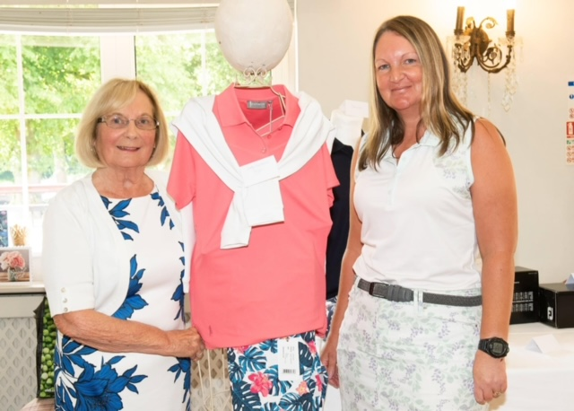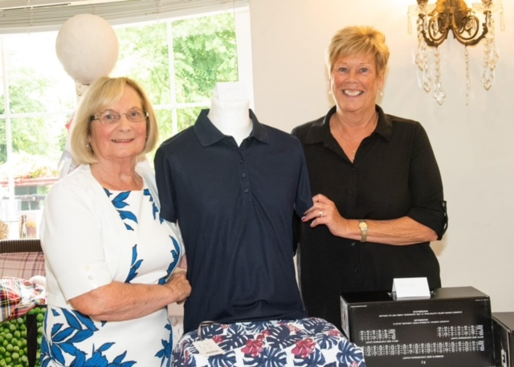

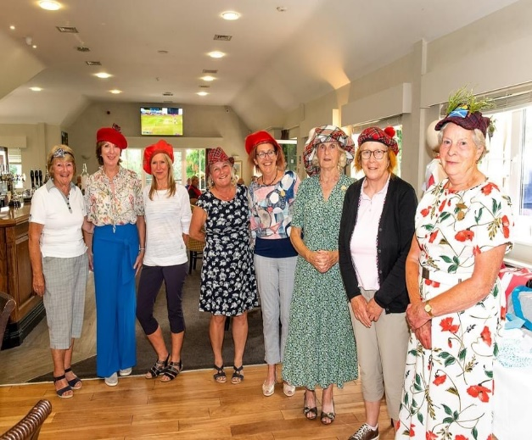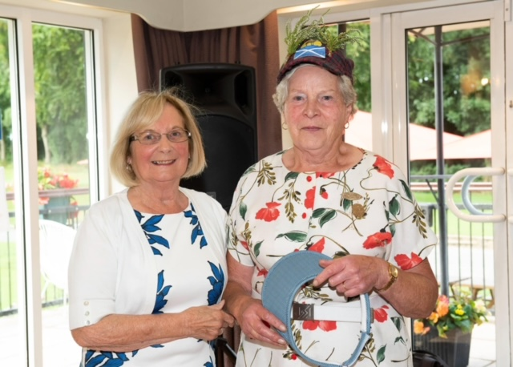

32 gentlemen entered Helena’s 9-hole evening competition which was won by Ian Paterson. The runner up was Stewart Taylor.
Helena also organised a junior competition which was won by Calista Newall. The runner up was Lily Shervill.

Our Ladies Open in May
What a great team effort. We were very keen not to lose this date on the club calendar because of low numbers and we wanted to ensure a great experience for our visitors. In the event 21 teams entered (86 ladies), the weather was glorious, and the ladies were delighted to be offered complimentary cakes at the halfway hut. Thank you to everyone who gave their time on the day and behind the scenes, especially Ruth Belcher and the ladies who donated the cakes, Jan Lamb for hosting the hut, Doreen Spencer and Ann Collier for managing the raffle, Gill Preece for managing registration, Lynne Stone and the comps team for all the administration before and after the competition and to Helena for the sweets and flowers, and not forgetting the kitchen and bar staff. Definitely also worth saying is a huge “well done” to the comps team who worked hard to master using the laptop, IG and the TV screen so that we could have a live leader board – a first for LHGC!

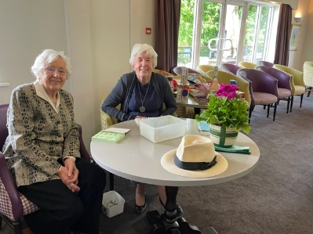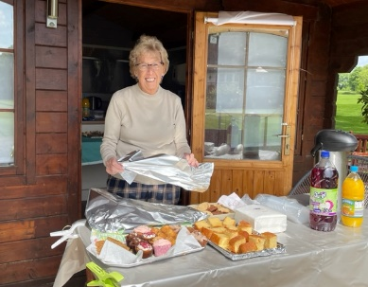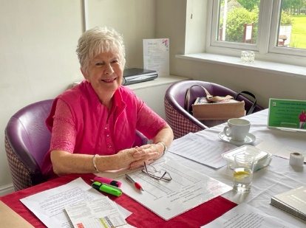

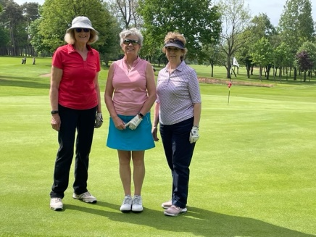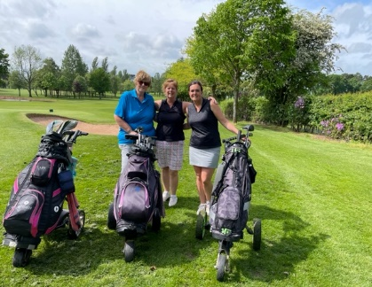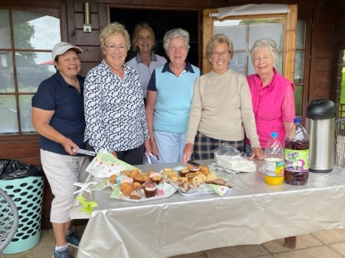

The winners of the Ladies Open was the LHGC team of Meg Laverie, Maureen Shepherd and Liz Johnson with a score of 76. A brilliant result ladies – well done! The runner-up team scored 75.

On the subject of Opens – The Summer Mixed Open
Another very successful event which had 26 teams enter, (104 players). Thanks again go to all the organisers particularly Lynne Stone, the Comps Team, Margaret Shanks, the kitchen and bar staff and anyone who gave their time to help with this event. The winning team had 89 points and the highest placed LHGC team with 83 points was that of Kevin Cole, Jo Cole, Chris Downing and Paul Reynolds. Well done all of you.

Competition Results
The season and the competition calendar are well under way now with a plethora of winners and runners-up to congratulate. Well done to all the winners and runners-up mentioned below.
Majors
The Ruth Lee Salver – The winner was Jenny Seager with a score of 72. The runner-up was Alison Totty who also scored 72.
Medals and Stablefords
May Stableford – Winner- Jo Wlazlo (36points), Runner-up- Denise Morton (35 points)
June Stableford – Winner- Julie Napier (30 points), Runner-up- Erica Tozer (30 points)
July Stableford – Winner -Jo Cole (44 points), Runner-up – Julie Napier (41 points)
Medal 5 – Winner -Julie Napier (71), Runner-up -Jo Wlazlo (74)
Medal 6 – Winner -Jo Wlazlo (67), Runner-up -Maureen Shepherd (71)
Medal 7 – Winner – Katelyn Wilkie (73), Runner-up -Ann Pratley (74)
Medal 8 – Winner -Ann Pratley (72), Runner-up – Margaret Hopkins (72)
Medal 10 – Winner- Ronnie Simpson* (71), Runner-up – Julie Cann (72) *Ronnie also won the Dot Gray Brooch (Past Captains Only)
Lady Captain’s Medal – Winner- Jo Wlazlo (77), Runner-up- Nicola Holdcroft (82)
Mixed Competitions
Captain’s Weekend Mixed Greensomes -Winners – Tim & Nicola Holdcroft (64)
Runners-up – Andy & Julie Napier (65)
July Mixed Gender Medal – 6 ladies entered this competition and once again we had a winner. Mary Harper won Division 3 with a score of 68.

County Comps
Ritchie Salver (QR) – Winner – Bernadette Micklewright (75), Runner-up – Helena Price (77)
Wynne Corrie K O Match Play – Winner- Jo Cole

NB Competition Date Changes –

- Thursday, 25th August, Joyce Fothergill Trophy (Major, 18 hole stroke play)
- Tuesday,30th August, Shuker Bowl (1), Thursday, September 1st, (Major, 2 x 18-hole stroke play)

Ladies EGM 7th July
As a result of the meeting, ladies have decided to reduce the minimum entry requirement for majors from 15 to 8 and to allow entry to majors on the day of the competition.

Some County News
Congratulations to Bernadette Micklewright for reaching the semi – finals of the County Championships. Bernadette thanked all the LHGC ladies for their messages of support and particularly Elizabeth Kenyon and Lady Captain, Helena Price who supported by attending the final played at Shifnal GC.

Huge congratulations to Katelyn Wilkie for winning the County Junior Championship. Abby Birchall (The Shropshire) was the runner- up and Sophie Brothwood (Wrekin) was third.

Katelyn is also doing extremely well with the Junior Scratch Team and currently the team has leapt to 1st place in the MNR Junior Scratch League

The County 2nd team is captained by Alice Drewnicki and had two further LHGC ladies – Bernadette Micklewright and Katelyn Wilkie when they beat Staffordshire 7-2 at the Wrekin on the 12thJuly. A brilliant result, ladies – well done.

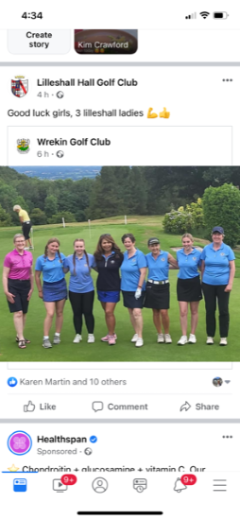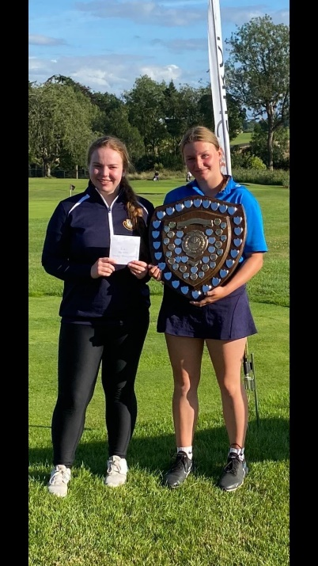
Katelyn – Junior County Champion (on the right)

Women in Golf
We are delighted with the results of our internet and Open Day promotional efforts. We have been very pleased to welcome 13 ladies on to our trial membership scheme, with 7 more taking part in the basic course. By all reports the women are thoroughly enjoying learning about our fabulous sport. Thank you to all those who helped with the Open afternoon, those who have volunteered to act as “buddies” and special thanks to Lisa Shervill for fostering the newcomers’ enthusiasm and promoting the game. Several of the ladies have already joined in with our 9&Wine events and seem to be very happy with the opportunity to meet other members.

9&Wine Evenings
These have again proved to be popular – we have enjoyed 4 meetings so far this summer. Everyone is welcome to join in these events – a nine-hole Texas scramble team competition played at approximately 4.40pm and followed by wine and chatter in the clubhouse. There are 2 evenings still planned – please join in if you can, the dates are shown below.

9&Wine 5 – Wednesday, 17th August. 9&Wine 6 – Monday, 19th September.

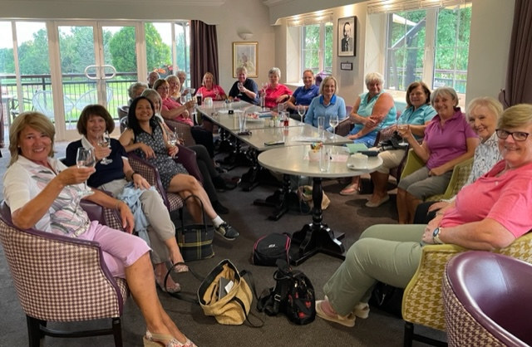

Matches –

The Leagues-
Our journeys in all three leagues (Mini, Handicap and Scratch) have now come to an end as none of the LHGC teams made it through to the next stages. Unfortunately, LHGC withdrew from the Scratch League as we were unable to field a team on one occasion. Nevertheless, thank you to all the ladies who played for our club. There were some very close matches played and I know we all did our very best on the day. Thanks also to our league organisers – Sue Everatt, Elizabeth Kenyon and Jo Cole.

Ladies Friendly Match Results – Shifnal (Away) 3-1 loss
Hawkstone (Away) -team event of 2 players from each club. Jo Cole & Ronnie Simpson in winning team
Shrewsbury (Home) – Lilleshall win -two and a half to one and a half

Mixed Friendly Match Results- Market Drayton (Home) – 4-3 win
Llanymynech (Away) – 3-5 loss
Ingestre (Home)- 5-3 win
Enville (Home) - 8-4 win.

Many thanks to all who have represented LHGC in the matches to date. Keep going Ladies! (and gents!). Also, thanks again to Jo Cole for all the hours of work she puts in to arranging these matches.

Dates for your diary

16th August – Lady President’s Day – please sign up via IG or in the changing room.

18th August – LHGC Annual General Meeting at 7.30pm in the clubhouse.

29th August – Margot Semple Trophy -a mixed greensomes. Enter via IG.

3rd September – Four Nations Event – Enter via IG. Email your team choice to Lynne Stone.

12th September – Ladies Pairs Open- Enter via IG. Time is running out to save this event as entries are currently very low.

6th October, – Lady Captain’s Charity Lunch with an outside speaker.
11th October – Seniors/Ladies fixture.
10th November, – Christmas Fayre.
Lady President’s Jubilee Oak Tree
Lady President, Ruth Belcher has proposed that we raise funds to plant an oak tree to commemorate the Queen’s Platinum Jubilee and to replace the tree by the 18th hole which is going to be felled because it is rotten. Some funds have already been given. Ruth has requested that instead of personal gifts on her day, ladies be invited to donate to this fund.

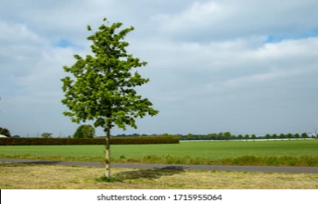

Newsletter written by Ronnie Simpson and agreed by Helena Price.

